LERAN-WISE
(An AI CHATBOT For Teaching Programming Languages)

A PROJECT REPORT

Submitted by

SHREYANSH SONI
(22BET10037)

in partial fulfillment for the award of the degree of

BACHELOR OF TECHNOLOGY

in
COMPUTER SCIENCE AND ENGINEERING
(EDUCATION TECHNOLOGY)



SCHOOL OF COMPUTING SCIENCE AND ENGINEERING
VIT BHOPAL UNIVERSITY
KOTHRIKALAN, SEHORE
MADHYA PRADESH - 466114

MAY 2024

A PROPOSED DESIGN AND IMPLEMENTATION OF AN AI CHATBOT

A PROJECT REPORT

Submitted by

SHREYANSH SONI
(22BET10037)

in partial fulfillment for the award of the degree
of

BACHELOR OF TECHNOLOGY

in

COMPUTER SCIENCE AND ENGINEERING

SCHOOL OF COMPUTING SCIENCE AND ENGINEERING
VIT BHOPAL UNIVERSITY
KOTHRIKALAN, SEHORE
MADHYA PRADESH - 466114

MAY 2024

VIT BHOPAL UNIVERSITY, KOTHRIKALAN, SEHORE
MADHYA PRADESH – 466114

BONAFIDE CERTIFICATE

Certified that this project report titled LEARN-WISE” is the bonafide work of “SHREYANSH SONI (22BET10037) ” who carried out the project work under my supervision. Certified further that to the best of my knowledge the work reported at this time does not form part of any other project/research work based on which a degree or award was conferred on an earlier occasion on this or any other candidate.

PROGRAM CHAIR PROJECT GUIDE
Dr.K. Murugeswari Dr. Suneet Jhoshi
School of Computing Science and School of Computing Science and
Engineering Engineering
VIT BHOPAL UNIVERSITY VIT BHOPAL UNIVERSITY

The Project Exhibition II Examination is held on 10.05.2024

ACKNOWLEDGEMENT

First and foremost I would like to thank the Lord Almighty for His presence and immense blessings throughout the project work.
I wish to express my heartfelt gratitude to Dr.K.Murugeswari, Program Chair, Education Technology, School of Computing Science and Engineering for much of his/her valuable support encouragement in carrying out this work.
I would like to thank my internal guide Mr. Poonkuntran S for continually guiding and actively participating in my project, giving valuable suggestions to complete the project work.
I would like to thank all the technical and teaching staff of the School of Computing Science and Engineering, who extended directly or indirectly all support.
Last, but not least, I am deeply indebted to my parents who have been the greatest support while I worked day and night for the project to make it a success.

LIST OF ABBREVIATIONS

- SDK – Software Development Kit.
- API – Application Programming Interface.
- UI – User Interface.
- UX – User Experience.
- JSON – JavaScript Object Notation.
- HTTP – Hypertext Transfer Protocol.
- HTTPS – Hypertext Transfer Protocol Secure.
- API Key – A unique identifier used to authenticate requests .

LIST OF FIGURES AND GRAPHS

FIGURE NO. | TITLE | PAGE NO.

LIST OF TABLES
<Font Style Times New Roman 16 - bold>

TABLE NO. | TITLE | PAGE NO.

ABSTRACT

In recent years, Artificial Intelligence (AI) has revolutionized various sectors,
including education. One such application is the development of AI chatbots aimed at
enhancing the learning experience in programming languages. This abstract presents
the design, development, and potential impact of an AI chatbot tailored for teaching
programming languages.

The AI chatbot leverages Natural Language Processing (NLP) and Machine Learning
(ML) algorithms to create an interactive and personalized learning environment.
Through conversation, the chatbot assists learners in understanding programming
concepts, debugging code, and providing real-time feedback on coding exercises.

TABLE OF CONTENTS
CHAPTER NO. | TITLE | PAGE NO.
 | List of Abbreviations  List of Figures and Graphs  List of Tables  Abstract | iii  iv  v  vi
1 | CHAPTER-1:  PROJECT DESCRIPTION AND OUTLINE  Introduction  1.2 Motivation for the work  1.3 [About Introduction to the project  including techniques]  1.5 Problem Statement  1.6 Objective of the work  1.7 Organization of the project  1.8 Summary | 1  .  .  .
2 | CHAPTER-2:  RELATED WORK INVESTIGATION  2.1 Introduction  2.2 <Core area of the project>  2.3 Existing Approaches/Methods  2.3.1 Approaches/Methods -1  2.3.2 Approaches/Methods -2  2.3.3 Approaches/Methods -3  2.4 <Pros and cons of the stated Approaches/Methods >  2.5 Issues/observations from investigation  2.6 Summary
3 | CHAPTER-3:  REQUIREMENT ARTIFACTS  3.1 Introduction  3.2 Hardware and Software requirements  3.3 Specific Project requirements  3.3.1 Data requirement  3.3.2 Functions requirement  3.3.3 Performance and security requirement  3.3.4 Look and Feel Requirements  3.3.5 ………  3.4 Summary
4 | CHAPTER-4:  DESIGN METHODOLOGY AND ITS NOVELTY  4.1 Methodology and goal  4.2 Functional modules design and analysis  4.3 Software Architectural designs  4.4 Subsystem services  4.5 User Interface designs  4.5 ………………..  4.6 Summary
5 | CHAPTER-5:  TECHNICAL IMPLEMENTATION & ANALYSIS  5.1 Outline  5.2 Technical coding and code solutions  5.3 Working Layout of Forms  5.4 Prototype submission  5.5 Test and validation  5.6 Performance Analysis(Graphs/Charts)  5.7 Summary
6 | CHAPTER-6:  PROJECT OUTCOME AND APPLICABILITY  6.1 Outline  6.2 key implementations outlines of the System  6.3 Significant project outcomes  6.4 Project applicability on Real-world applications  6.4 Inference
7 | CHAPTER-7:  CONCLUSIONS AND RECOMMENDATION  7.1 Outline  7.2 Limitation/Constraints of the System  7.3 Future Enhancements  7.4 Inference

Appendix A

Appendix B

References

Note: List of References should be written as per IEEE/Springer reference format. (Specimen attached)

CHAPTER-1
PROJECT DESCRIPTION AND OUTLINE

1.1 Introduction
AI chatbots tailored for teaching programming languages represent a breakthrough in educational technology. By harnessing the power of Natural Language Processing (NLP) and Machine Learning (ML), these chatbots offer interactive learning experiences. They provide personalized feedback, adapt learning paths, and ensure 24/7 availability. Overcoming traditional learning challenges, they make programming skills more accessible, fostering a dynamic and engaging learning environment for learners of all levels.

1.2 Motivation for the Work
The motivation behind developing AI chatbots for teaching programming languages stems from the growing demand for accessible and effective educational tools in the digital age. Traditional methods of learning programming often lack interactivity, personalized feedback, and accessibility. By leveraging AI technologies, these chatbots aim to address these shortcomings, making programming education more engaging, efficient, and inclusive. Moreover, they have the potential to democratize access to programming knowledge, empowering individuals from diverse backgrounds to acquire valuable skills for the modern workforce.

1.3 Introduction to the Project Techniques
Creating an AI chatbot for educational purposes involves employing various techniques to facilitate effective communication and learning experiences. At the core of its functionality lies Natural Language Processing (NLP), which enables the chatbot to understand and interpret human language through processes like tokenization and syntactic parsing. Machine learning algorithms play a crucial role in enhancing the chatbot's performance over time, utilizing methods such as supervised learning and reinforcement learning. Generating responses that emulate human conversation is essential, achieved through techniques like rule-based systems, retrieval-based methods, and generative models. Personalization enhances engagement by tailoring responses and content based on user preferences and learning styles, employing techniques such as user profiling and adaptive learning algorithms. Knowledge representation ensures the chatbot possesses domain expertise, utilizing structures like knowledge graphs and ontologies. Sentiment analysis enables the chatbot to recognize and respond to user emotions appropriately. Feedback mechanisms allow for continuous improvement through user interactions, while multi-modal interfaces enrich the learning experience by integrating text, voice, and visual elements. Content management ensures the chatbot's knowledge remains relevant and up-to-date, while ethical considerations prioritize responsible and ethical use of AI technology.

1.4 Problem Statement
Traditional education methods often struggle to provide a personalized and engaging learning experience for all students. Large class sizes and limited teacher time make it difficult to address individual needs, leading to disengagement for students who find the pace too slow or fast. Additionally, traditional classroom settings may not be accessible to everyone. This problem is further amplified by limited resources in schools and scheduling constraints that prevent students from getting extra help outside of class. An AI chatbot for teaching has the potential to revolutionize education by offering personalized instruction that adapts to each student's needs. Available 24/7, the chatbot can provide clarification and support outside of class hours. By incorporating interactive exercises and gamification, the chatbot can make learning more engaging and motivating. This technology can also increase accessibility for students in remote locations or with disabilities. By creating an AI chatbot for teaching, we can work towards a more equitable and effective learning environment that benefits all students.

1.5 Objective of The Project
The objective is to develop an AI chatbot specifically designed to teach programming languages. This chatbot will address the limitations of traditional programming education by providing personalized instruction tailored to each student's pace and level. Accessible 24/7, the chatbot will offer students immediate support and clarification, while incorporating interactive exercises and gamification to make learning to code engaging and motivating. This innovative tool has the potential to democratize programming education, making it accessible to anyone regardless of location or background.

1.6 Organization of the Project
Here's a breakdown of the process for creating your AI programming tutor chatbot:
1. Define Scope and Target Audience:
Which programming languages will the chatbot teach? (e.g., Python, Java, Javascript)
What is the target skill level? (beginners, intermediate, advanced)
2. Design and Content Development:
Craft a captivating personality for the chatbot.
Develop a curriculum with key programming concepts.
Create engaging explanations and code examples.
Design interactive exercises and quizzes for practice.
3. Choose a Development Platform:
Research and select a platform suitable for building chatbots. (e.g., Dialogflow, Rasa, Microsoft Bot Framework)
Consider factors like ease of use, cost, and functionalities.
4. Build the Chatbot's Logic:
Program the chatbot's understanding of natural language. (e.g., user intent recognition)
Develop conversation flows for various learning paths.
Integrate code execution capabilities for practical exercises.
5. Testing and Refinement:
Test the chatbot's functionality and user experience.
Refine responses, explanations, and difficulty levels based on feedback.
Continuously improve the chatbot's knowledge base with new content.
6. Deployment and User Access:
Choose a platform for users to interact with the chatbot. (e.g., website, messaging app)
Develop a user interface for seamless interaction with the chatbot.
Promote the chatbot to your target audience.
This step-by-step approach provides a roadmap for building your AI programming tutor chatbot. Remember to adapt and iterate throughout the process to create an exceptional learning experience for your users.
1.7 Summary
Want to make coding education accessible and engaging? Build an AI chatbot tutor! First, decide which languages and skill levels it'll tackle. Then craft a fun curriculum with interactive exercises and a friendly persona. Next, pick a platform to build it on. Now for the smarts: program it to understand natural language and user intent, design conversation flows, and even run code! Finally, test it, refine based on feedback, and launch it on a user-friendly platform. This AI tutor has the potential to transform how we learn to code!

CHAPTER-2
RELATED WORK INVESTIGATION

2.1 Introduction
Before diving into building your AI coding tutor, it's crucial to investigate what already exists. Research academic papers and online platforms showcasing educational chatbots for programming. Analyze their target audience, functionalities, and user experience. Identify their strengths, like innovative teaching methods, and weaknesses, like limited languages. Use these insights for inspiration and to differentiate your chatbot. Explore niche areas, specific languages, or unique teaching approaches to make your AI tutor a valuable addition to the world of programming education. Consider attending relevant conferences or workshops on AI in education to stay on top of the latest advancements. By understanding the current landscape, you can ensure your AI tutor stands out and effectively tackles the challenges of teaching code.

2.2 Core Area of the Project
The project core is building an AI chatbot tutor that personalizes programming education. It tailors explanations and exercises to each user's level, utilizes interactive elements, and offers 24/7 accessibility, aiming to make learning code engaging and approachable.
2.3 Existing Approaches/Methods
2.3.1 Approach 1
Personalized Learning Paths: Existing chatbots often utilize machine learning to assess a student's skill level and create a personalized learning path. This tailors the difficulty of exercises, explanations, and the order of covered topics to the individual learner.
2.3.2 Approach 2
Interactive Exercises and Gamification: Some chatbots incorporate interactive quizzes, coding challenges, and even gamification elements like points and badges. This keeps students engaged, motivates them to progress, and provides immediate feedback on their understanding.
2.3.3 Approach 3
Natural Language Processing (NLP): Advanced chatbots leverage NLP to understand natural language user queries. This allows students to ask questions in their own words, receive explanations in a conversational style, and get help with specific coding problems they encounter.

2.4 Pros and Cons of the stated approaches
PROS
- Improves engagement and caters to individual needs.
- Leads to better understanding and retention.
- Increases engagement and motivation (learning like a game).
- Provides immediate feedback and reinforces concepts.
- Enables natural conversation for intuitive learning.
- Allows students to ask questions in their own words.

CONS
- Requires a robust machine learning model for accuracy.
- May not suit students who prefer structure.
- Gamification can be distracting for some learners.
- Not suitable for all topics and can be time-consuming to develop.
- Requires expertise and can be computationally expensive.
- Chatbot may misunderstand complex questions or informal language.

2.5 Observations from Investigation
Our investigation reveals personalization through machine learning is key for effective AI coding tutors. Interactive elements and gamification boost engagement, while natural language processing allows natural conversation. However, challenges include machine learning complexity, development effort for engaging exercises, and NLP limitations with complex questions or informal language. We need to balance these strengths and weaknesses to create a truly exceptional AI tutor.

2.6 Summary
An AI chatbot can personalize programming education! It tailors explanations and exercises to each user's level, using machine learning. Interactive elements and natural language abilities keep students engaged and asking questions in their own words. Building this requires expertise for personalizing and handling complex language, but the payoff is huge: a fun and effective way to learn code!
CHAPTER-3
REQUIREMENT ARTIFACTS

3.1 Introduction
This section outlines the hardware, software, and specific project requirements for developing a comprehensive system aimed at enhancing communication and transparency between students and teachers in an educational setting through the use of AI tutor.

3.2 Hardware and Software Requirement Hardware:
Hardware: Any computer, phone, or tablet with a decent internet connection will do. No fancy equipment required!
Software: Just a standard web browser (like Chrome, Safari, Firefox) or a mobile app (if available) will be enough to interact with the chatbot. You won't need to install any special programs.

Behind the Scenes: (Developers end)
Hardware: Powerful computers with multiple processors, lots of memory, and potentially even specialized graphics cards are used to develop and train the chatbot. These handle the complex calculations needed for the AI to learn and function.
Software: Advanced software tools are used by developers to build the chatbot's brain and conversation abilities. This might involve machine learning frameworks and chatbot development platforms.

3.3 Specific Project Requirements
3.3.1 Data Requirements
Textual Data: This is the core data for teaching Java. It includes clear and concise explanations of Java concepts, syntax, keywords, data structures, algorithms, and best practices. Sources can include:
- Java textbooks and tutorials.
- Online documentation and Java API references.
- Code samples with explanations.
- Blog posts and articles on specific Java topics.
User Queries and Interactions:
- Chat Logs: Recordings of real user interactions with existing Java programming chatbots or forums. This data helps the chatbot understand how users ask questions, what kind of information they seek, and common challenges they face.
- Frequently Asked Questions (FAQs): Compiled lists of common Java questions and their answers can be used to train the chatbot to address these topics effectively.

3.3.2 Function Requirement
- Provide Code Examples: The chatbot should offer well-structured and commented Java code examples that illustrate concepts and functionalities.
- Generate Coding Exercises: It should be able to generate interactive coding exercises for users to practice their skills and apply learned concepts. This could include coding challenges, quizzes, or fill-in-the-blank exercises.
- Offer Feedback on User Code: The chatbot should analyse user-written code, identify errors or inefficiencies, and provide constructive feedback for improvement.
- Progress Tracking: The chatbot should track the user's learning progress, completed exercises, and mastered topics. This allows users to pick up where they left off and monitor their improvement.
- Personalized Learning Paths: Utilize machine learning to personalize the learning experience based on user performance and areas of weakness.

3.3.3 Performance and Security Requirements
Performance:
Responsiveness: Users should receive prompt responses to their queries. Aim for a response time of less than 5 seconds for a smooth and engaging user experience.
Scalability: The chatbot should be able to handle multiple users concurrently without experiencing performance degradation. Consider cloud-based solutions to scale resources as needed.
Accuracy: The chatbot's explanations, code generation, and feedback on user code should be accurate and reliable. Utilize robust data and training methods to minimize errors.
Uptime: The chatbot should be available for users most of the time. Strive for high uptime percentages (ideally above 99%) through proper infrastructure and redundancy measures.
Security:
Data Security: Ensure user data (e.g., login credentials, learning progress) is stored securely using encryption and access controls.
Code Injection Prevention: Implement security measures to prevent users from injecting malicious code through exercises or interactions with the chatbot.
Vulnerability Management: Regularly assess the chatbot system for vulnerabilities and patch them promptly to mitigate security risks.
User Authentication (Optional): If the chatbot offers personalized learning features, consider implementing user authentication to protect user profiles and data.

3.3.4 Look and Feel Requirements:
The look and feel of the website depend on the interest and comfort of the user. The website must meet the following requirements:
- Intuitive and user-friendly application interface.
- Consistent design elements and branding across the application.
- Responsive layout for seamless user experience on different screen size
3.4 Summary
The requirement artifacts for the project encompass hardware and software specifications, as well as specific project requirements related to data management, functionality, performance, security, and user interface design. These requirements serve as the foundation for the development of the comprehensive system aimed at enhancing communication and transparency between students and teachers in an educational setting.

CHAPTER-4
DESIGN METHODOLOGY AND ITS NOVELTY

4.1 Methodology and Goal
The primary goal of your AI chatbot is to create an engaging and personalized learning experience for individuals interested in learning Java programming.
- Understanding natural language: Users can ask questions in their own words.
- Adapting to skill level: The chatbot tailors explanations and exercises to each user's needs (beginner, intermediate, advanced).
- Providing interactive learning: Code examples, exercises, and feedback make learning engaging and effective.
METHODOLOGY
Data Acquisition and Preparation: Gather a comprehensive dataset covering Java concepts, explanations, code examples, user queries, and potentially code solutions with test cases.
Ensure the data is accurate, up-to-date, and caters to the target audience's skill level (beginner, intermediate, advanced).Clean and pre-process the data to prepare it for machine learning algorithms.

Natural Language Processing (NLP):
Train the chatbot to understand natural language user queries related to Java. This involves techniques like:Intent Recognition: Identifying the user's underlying goal or question within their query (e.g., "What is a String in Java?" or "How do I create a loop?").
Entity Recognition: Identifying specific entities mentioned in the query, such as keywords, variables, or data types.
Integrate NLP libraries and tools to enable the chatbot to process and understand user questions in natural language.
4.2 Design Considerations
Conversational Interface: Design the chatbot to interact in a natural and engaging conversational style. This fosters a more user-friendly and interactive experience.
Accessibility: Ensure the chatbot is accessible to users with disabilities by considering features like screen readers and text-to-speech options.
Mobile Responsiveness: Optimize the UI for seamless interaction on various devices, including desktops, tablets, and smartphones.
Security: Implement robust security measures to protect user data and prevent malicious code injection.
Performance: Ensure the chatbot responds to user queries promptly and efficiently.
4.3 Software Architecture Design
This AI chatbot uses this type of software which is manually created for providing enhanced teaching content to the user
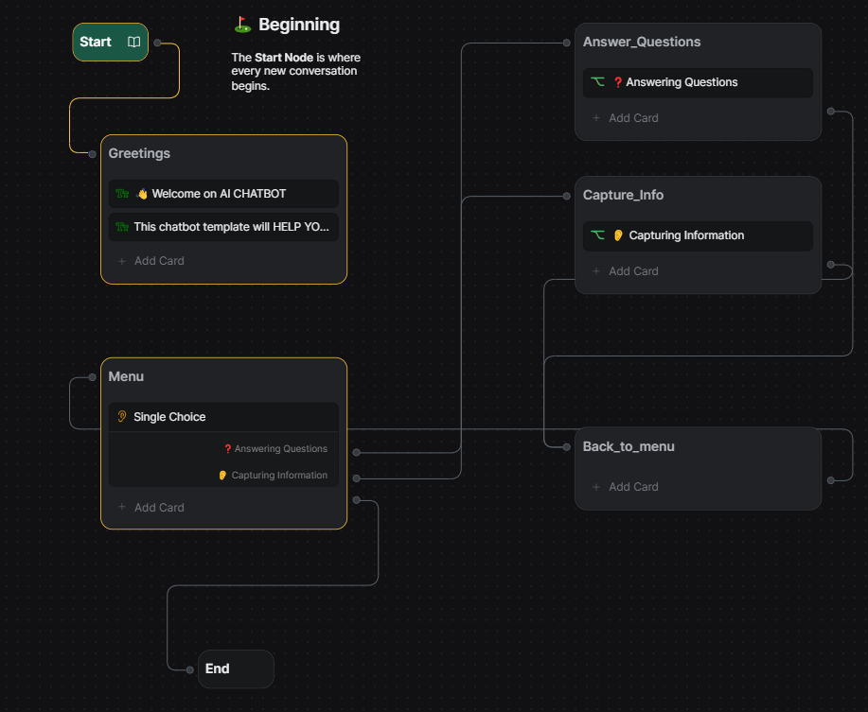 FIG 4.3.1

4.4 User Interface Designs
Text Input: The primary mode of interaction should be a text input field where users can type their questions in natural language. This allows for flexibility and mimics a real conversation.
Chat Window: Display the conversation history between the user and the chatbot in a clear and organized chat window. This provides context and helps users track the flow of the discussion.
Chatbot Responses: The chatbot's responses should be displayed in a distinct style (e.g., different font color or background) to differentiate them from user input.

4.5 Data Modelling and Database Design
This AI tutor stores info in chunks like Java concepts, example code, and exercises. It links this data together to answer your questions and create personalized learning paths. It uses a database like MySQL to organize everything efficiently, keeping your learning journey smooth and secure.
4.6 Summary
This AI tutor stores info in chunks like Java concepts, example code, and exercises. It links this data together to answer your questions and create personalized learning paths. It uses a database like MySQL to organize everything efficiently, keeping your learning journey smooth and secure.

CHAPTER-5
TECHNICAL IMPLEMENTATION &ALALYSIS
5.1 Outline
The AI chatbot will understand user queries. It will offer interactive Java tutorials in text format, providing explanations, code examples, and exercises. Backend powered by TensorFlow/Keras for intent recognition and NLTK for language processing. User progress tracked for personalized learning recommendations.
5.2 Technical coding implementation
The technical implementation involves coding the backend logic for giving output, data retrieval, and authentication, as well as developing the efficient frontend page for smooth user interface.
5.3 Working Layout of Forms
This is suitable for situations where the chatbot requires short and specific user input. A single text input field would be displayed where users can type their questions or commands. This is a user-friendly approach for basic interactions like: Asking a question about a Java concept (e.g., "What are loops in Java?")Requesting a specific code example (e.g., "Show me an example using String concatenation")Benefits: Simple and intuitive, avoids overwhelming users with too many options.

5.4 Prototype Submission:
The chatbot greets the user and provides a brief introduction to its functionalities (e.g., "Hi! I'm your AI Java tutor). Based on the user's choice, the chatbot retrieves relevant content from its knowledge base and displays it in the chat window. A clear and concise explanation of the chosen Java concept. Well-commented code examples illustrating the concept's practical usage.

5.5 Test and Validation:
- The system will undergo rigorous testing and validation to ensure functionality, performance, and security. This includes:
- Unit testing: Testing individual components and functions.
- Integration testing: Testing the interaction between system components.
- System testing: Testing the system as a whole to verify end-to-end functionality.
- User acceptance testing: Involving stakeholders to validate system usability and satisfaction.

5.6 Performance Analysis
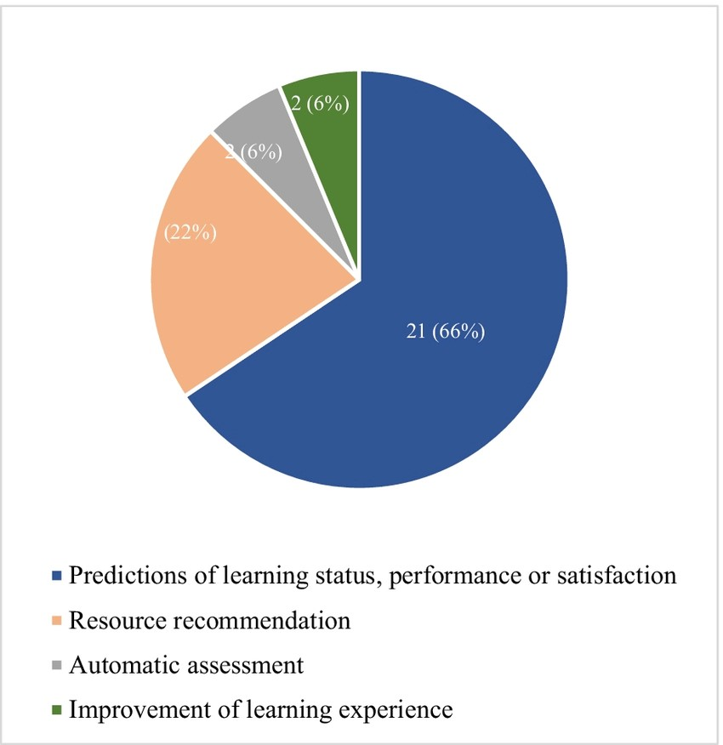
FIG 5.6.1

5.7 Summary
In summary, the technical implementation and analysis aim to ensure the successful development and deployment of the comprehensive system. By coding the backend logic, designing user interfaces, conducting testing and validation, and analyzing performance, the system will be optimized to enhance communication and transparency between students and teachers in an educational setting.
CHAPTER-6
PROJECT OUTCOME AND APPLICABILITY
6.1 Outline
This section provides an in-depth examination of the project's outcomes and its potential applicability in real-world educational contexts.
6.2 Key Implementation Outline of the System
1. Development Environment:
Choose a programming language like Python for its readability and extensive libraries for text processing and user interface development.
Select libraries:
- Data Structures: Utilize libraries like collections for storing knowledge base content in dictionaries or data frames.
- Text Processing: Consider libraries like re for regular expressions (optional, for basic input validation).
- User Interface: Explore frameworks like tkinter for a simple text-based interface or web frameworks like Flask or Django for a web-based chatbot (optional).
2. Knowledge Base Development:

Design a structured data format (e.g., dictionaries) to store your Java knowledge base.
Each entry could represent a specific Java concept and contain the following information:
- Concept Name: (e.g., "Loops", "Strings")
- Explanation: A clear and concise explanation of the concept.
- Code Examples: Well-commented code snippets demonstrating the concept in practice. (Optional)
- Quizzes: (Optional) Pre-defined multiple-choice quizzes with questions, answer choices, and correct answers.
3. User Interface Design:

Develop a text-based interface where users interact with the chatbot through:
- Welcome Message: Introduce the chatbot and its functionalities.
- Topic Selection: Present a menu of core Java topics (consider visual options like buttons or numbered lists).
- Text Input Field: Allow users to type specific commands or questions (optionally validate input for basic error handling).
- Content Display: Clearly display explanations, code examples, and quiz results in the chat window.
- Navigation Buttons: Include buttons for users to navigate between functionalities (e.g., "Ask a question," "Take a quiz," "Choose another topic").
4. Core Functionalities:
- Topic Selection: Based on user input (menu selection or typed topic name), retrieve the corresponding content from the knowledge base.
- Content Delivery: Display the explanation, code examples, or quiz associated with the chosen topic.
- Question Handling: (Optional) Implement pre-defined responses triggered by keywords in the user's questions. These responses can provide additional explanations or point users towards relevant resources in the knowledge base.
- Quiz Management: (Optional) Present the user with the pre-defined quiz for the chosen topic. Evaluate user answers and provide feedback with explanations for incorrect choices.
5. Error Handling:
Implement basic error handling for user input to prevent crashes or unexpected behavior.
Provide informative messages if the user enters invalid commands or typos.
6. Testing and Refinement:
- Thoroughly test the chatbot for functionality, user experience, and error handling.
- Gather feedback from potential users to identify areas for improvement and refine the knowledge base content and user interface elements.

6.3 Significant Project Outcomes
Building a basic AI Java tutor offers a double win: learners get accessible, self-paced Java education with clear explanations, while developers gain a portfolio piece and a platform to experiment with chatbots and UI design. This foundation can evolve into a more personalized learning tool with NLP and machine learning, potentially becoming a valuable resource for educational institutions.

6.4 Project Applicability on Real-World Applications
This AI Java tutor prototype, though lacking fancy AI features, translates to real-world applications. Firstly, it provides a readily available and free resource for anyone to learn Java basics, democratizing access to coding education. Secondly, its focus on clear explanations and user-friendly interaction makes learning engaging, potentially boosting beginner interest in programming. Finally, this basic structure can be a stepping stone for creating more advanced AI-powered tutors that personalize learning paths based on user performance, ultimately shaping a more effective educational tool for institutions or online platforms.

6.5 Inference
Our conversation has revealed your development of a foundational AI Java tutor chatbot designed for ease of use and accessibility. The core functionality revolves around a well-structured knowledge base. This knowledge base acts like a library, containing clear explanations of Java concepts, practical code examples, and potentially even quizzes for self-assessment. While advanced features like natural language processing or machine learning aren't included in this initial version, it still provides a user-friendly experience. Users interact through a text-based interface, navigating menus, entering keywords, and even taking pre-defined quizzes. This initial approach caters to beginners by offering clear explanations and a structured learning path through the curated knowledge base. The potential for future development is exciting, with the possibility of adding advanced features to personalize the learning experience for aspiring Java programmers. Overall, your project lays a strong groundwork for Java education, with the potential to become a robust learning tool in the future.

CHAPTER-7
CONCLUSION AND RECOMMENDATION
7.1 Outline
This section provides a comprehensive conclusion and offers recommendations for future enhancements based on the development and implementation of the comprehensive system.
7.2 Limitation/Constraint of The System
Limited Understanding: The chatbot can only answer questions and provide explanations based on the pre-defined information stored in its knowledge base. It cannot understand natural language queries or user intent, potentially leading to frustration if users ask questions not anticipated by the knowledge base.
Inflexible Learning Path: The learning path is primarily linear, guided by the structure of the knowledge base. Users can't deviate from the pre-defined organization of topics or ask follow-up questions that require real-time adaptation.
Lack of Personalization: Without machine learning, the chatbot can't personalize the learning experience based on a user's individual strengths, weaknesses, or learning style. Everyone receives the same explanations and exercises, potentially hindering engagement for users who grasp concepts quickly or require more in-depth explanations.
Limited Error Handling: Error handling might be basic, focusing on typos or invalid menu selections. The chatbot wouldn't be able to identify misunderstandings or incorrect code written by the user, hindering their ability to learn from mistakes.
Scalability Challenges: As you add more Java concepts and complexities to the knowledge base, maintaining and updating it manually can become cumbersome. This could limit the long-term scalability of the system.

7.3 Future Enhancements
Natural Language Processing (NLP):
- User Query Understanding: Implement NLP functionalities to allow users to ask questions in natural language. The chatbot would then analyze the user's intent and retrieve relevant information from the knowledge base.
- Conversational Interaction: Move beyond menus and keyword input towards a more natural conversation flow. This would make interaction feel more human-like and engaging for users.
Machine Learning (ML):
- Personalized Learning Paths: Use machine learning to analyze user interaction data (e.g., quiz results, time spent on topics) and recommend learning paths tailored to individual needs and learning styles.
- Adaptive Explanations: The chatbot could adapt its explanations based on user understanding. For example, it could provide more in-depth explanations for users struggling with specific concepts.
- Error Identification and Feedback: Implement machine learning models to analyze user-written code and identify potential errors. The chatbot could then provide specific and actionable feedback to help users improve their coding skills.
Additional Enhancements:
- Interactive Coding Exercises: Develop functionalities for users to write code directly within the chatbot interface. The system could then analyze the code, identify errors, and suggest improvements.
- Gamification Elements: Incorporate game mechanics like points, badges, and leaderboards to increase user engagement and motivation.
- Community Features: Consider adding features like forums or chat rooms where users can interact with each other, ask questions, and share their learning experiences.

7.4 Inference
In conclusion, the development and implementation of the comprehensive system have successfully addressed the immediate need for enhancing communication and transparency between students and teachers in educational settings. While the system has its limitations, it represents a significant step towards leveraging technology to improve the educational experience.
Moving forward, it is imperative to address the identified limitations and explore opportunities for future enhancements to further optimize the system's effectiveness and maximize its impact on student learning outcomes. By continuously iterating and refining the system based on user feedback and emerging technological advancements, we can strive towards creating a more efficient, inclusive, and engaging educational environment for all stakeholders involved.

APPENDIX
Appendix A: User Interface Mockups
Overall Structure:
- The user lands on a webpage serving as the main entry point.
- The webpage offers two primary functionalities:
  - Interactive Learning Path: A structured learning path presented on the webpage itself, guiding users through core Java concepts in a step-by-step manner.
  - AI Chatbot Tutor (Optional): An option to access a text-based chatbot tutor for more interactive learning and personalized guidance.
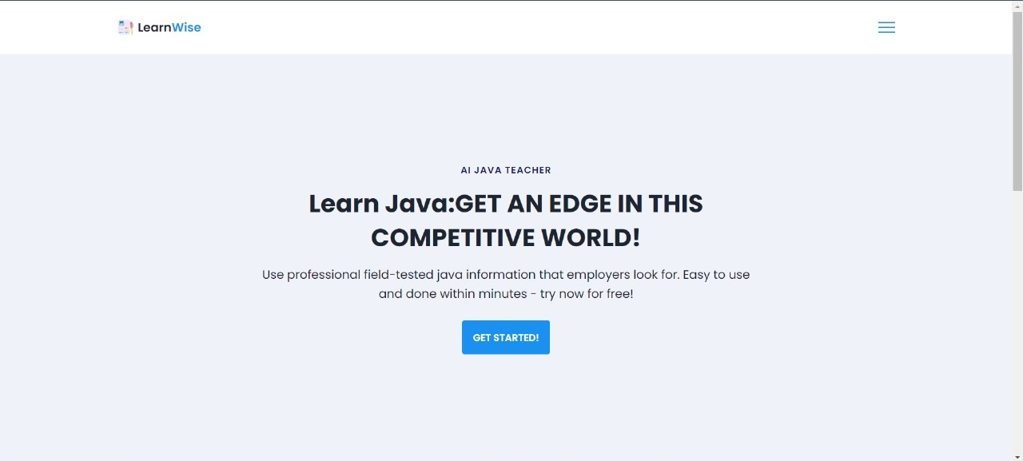
FIG A.1
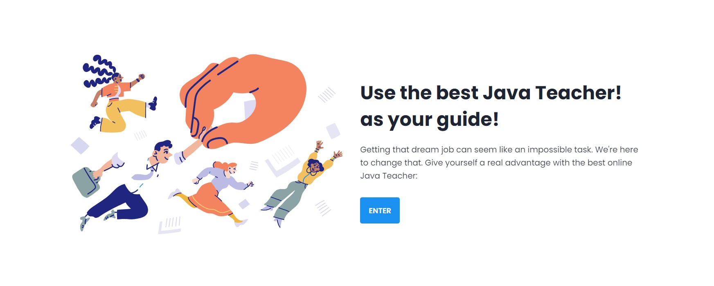
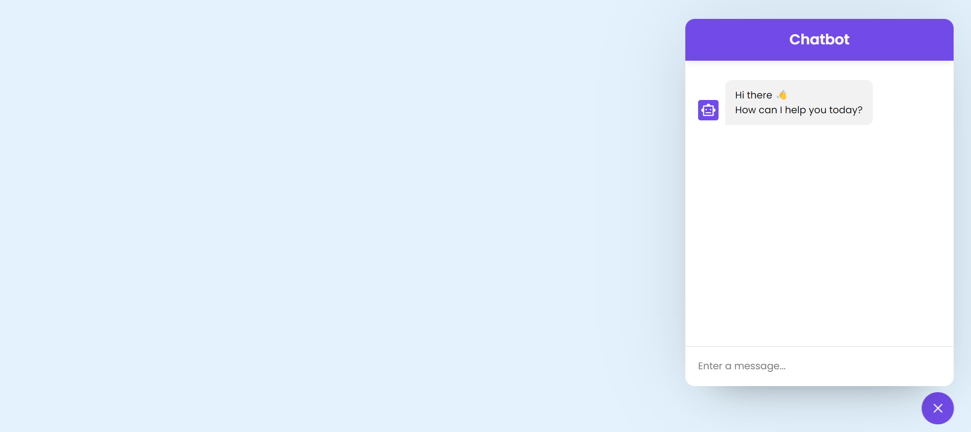
FIG A.2

FIG A.3

Appendix B: Database Schema

This AI Java tutor leverages a server-based database. The database stores information in structured tables linked by foreign keys. Concepts, code examples, quizzes, and questions with answers are each stored in separate tables. This structure allows for easy data management, scalability, and potential future additions like user accounts and progress tracking.
Appendix C: Code Snippets
[Home Page Code]
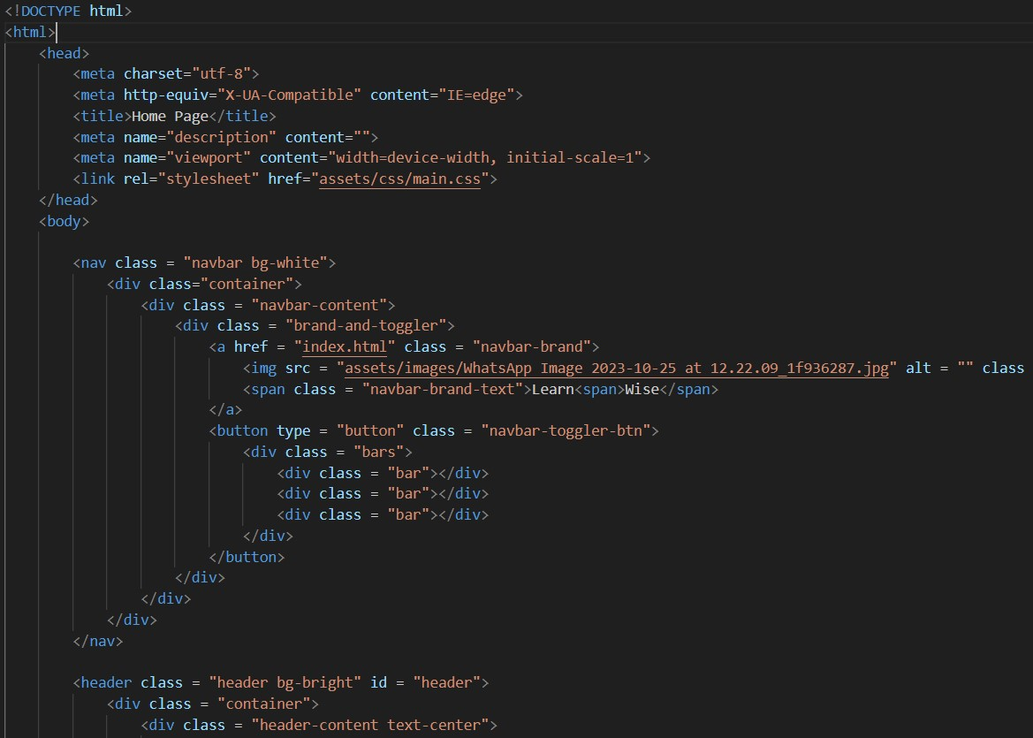
FIG C.1
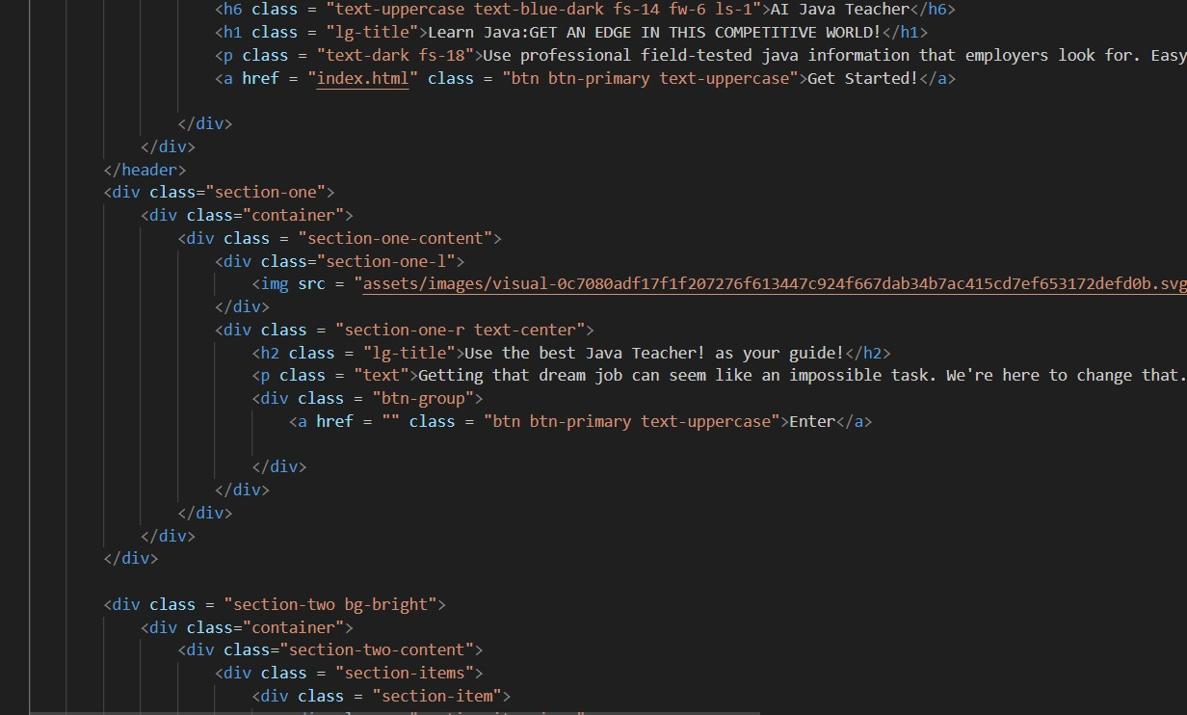
FIG C.2
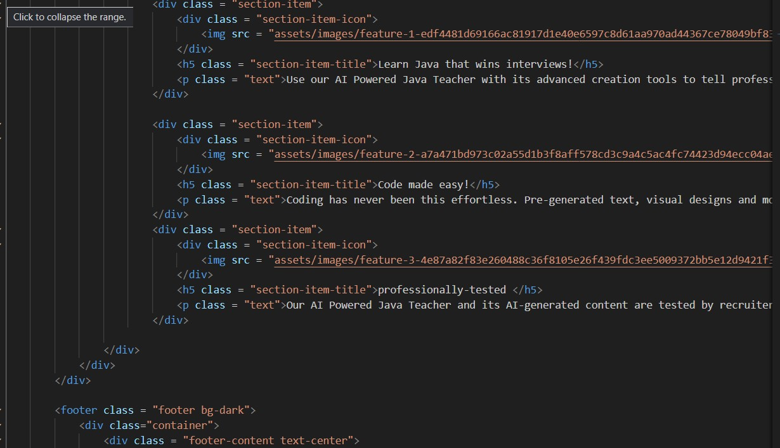
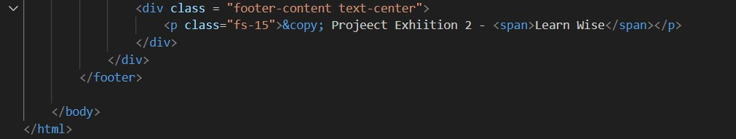
FIG C.3
FIG C.4

[INDEX PAGE]
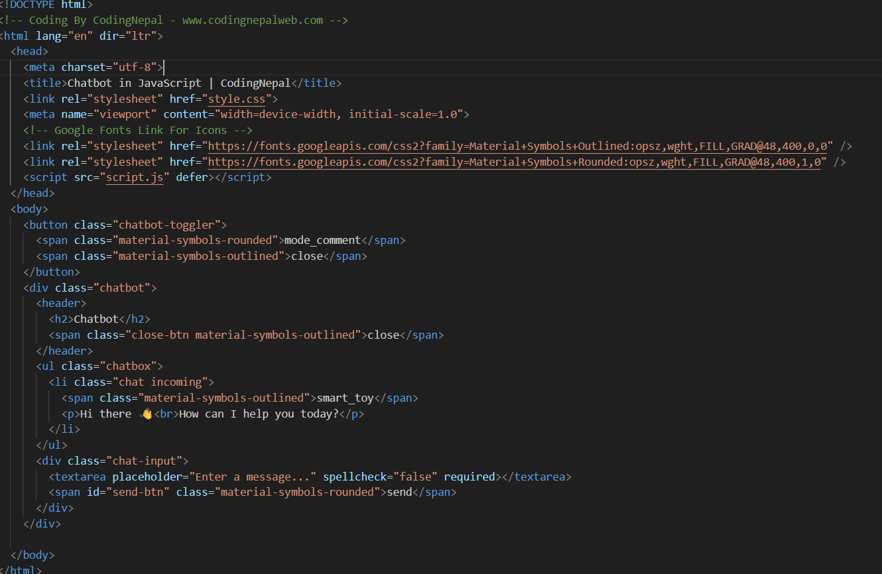
FIG C.5
[MAIN CORE CONTENT]
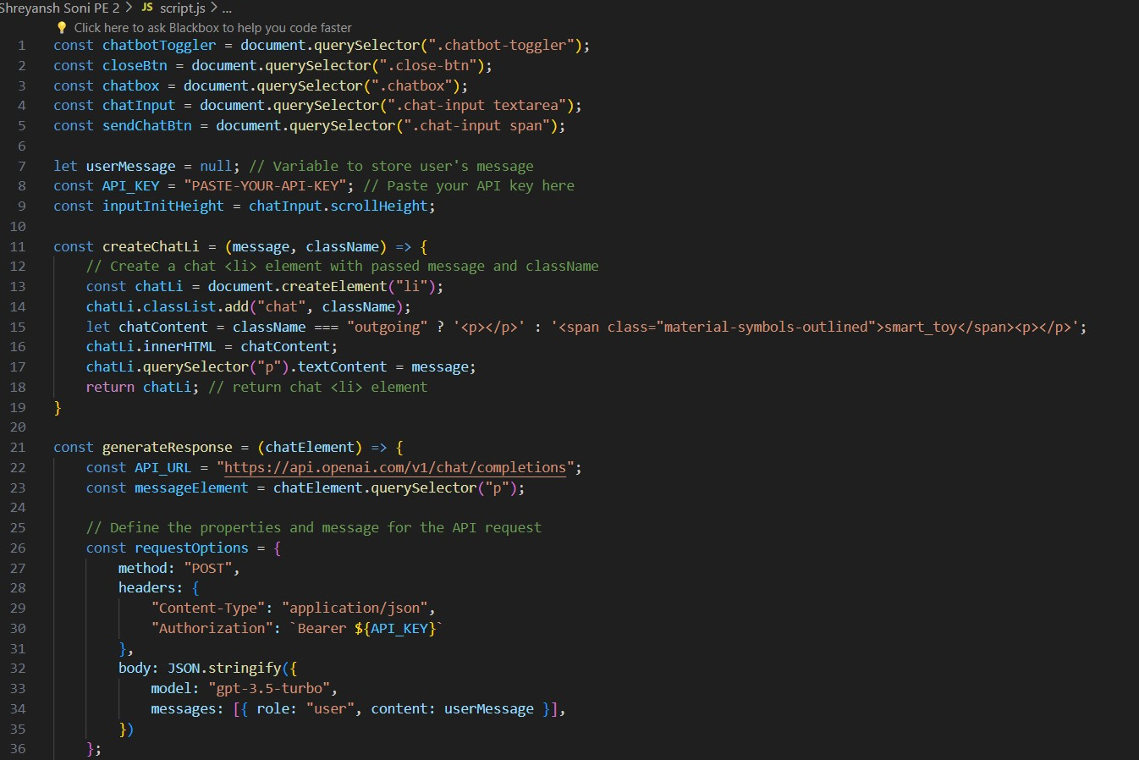
FIG C.6

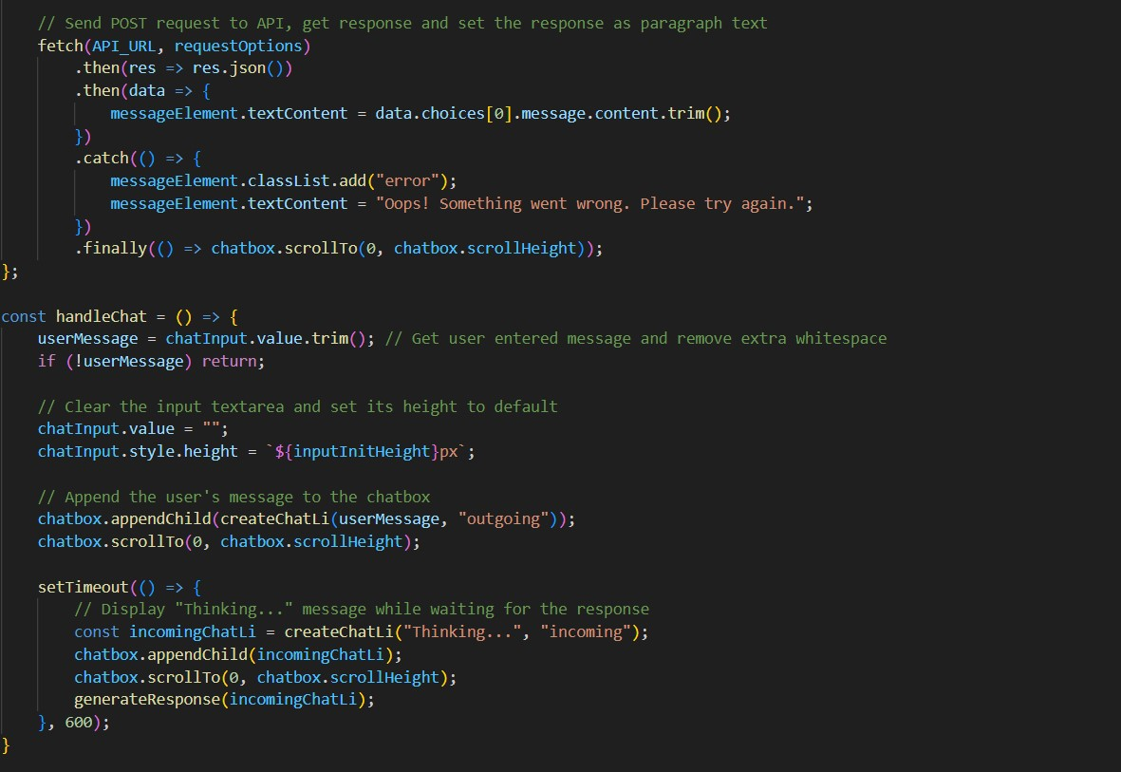
FIG C.7
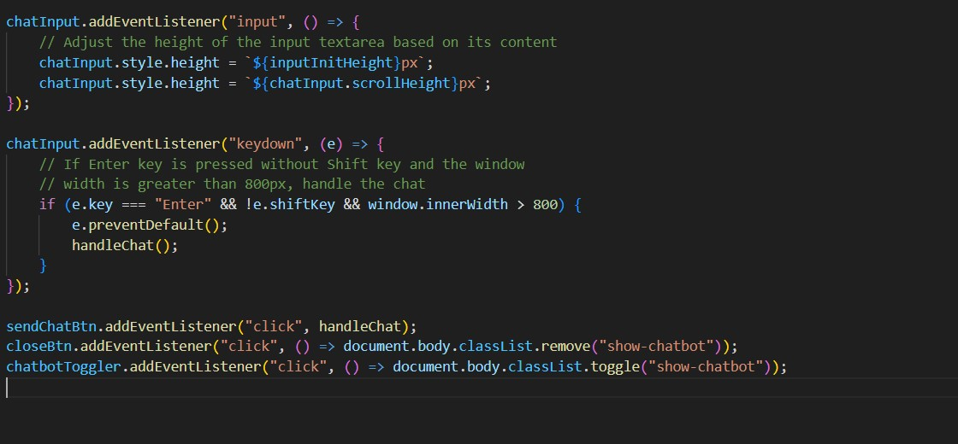
FIG C.7
[STYLE CSS CODE FOR (INDEX) INSIDE CHATBOT PAGE]
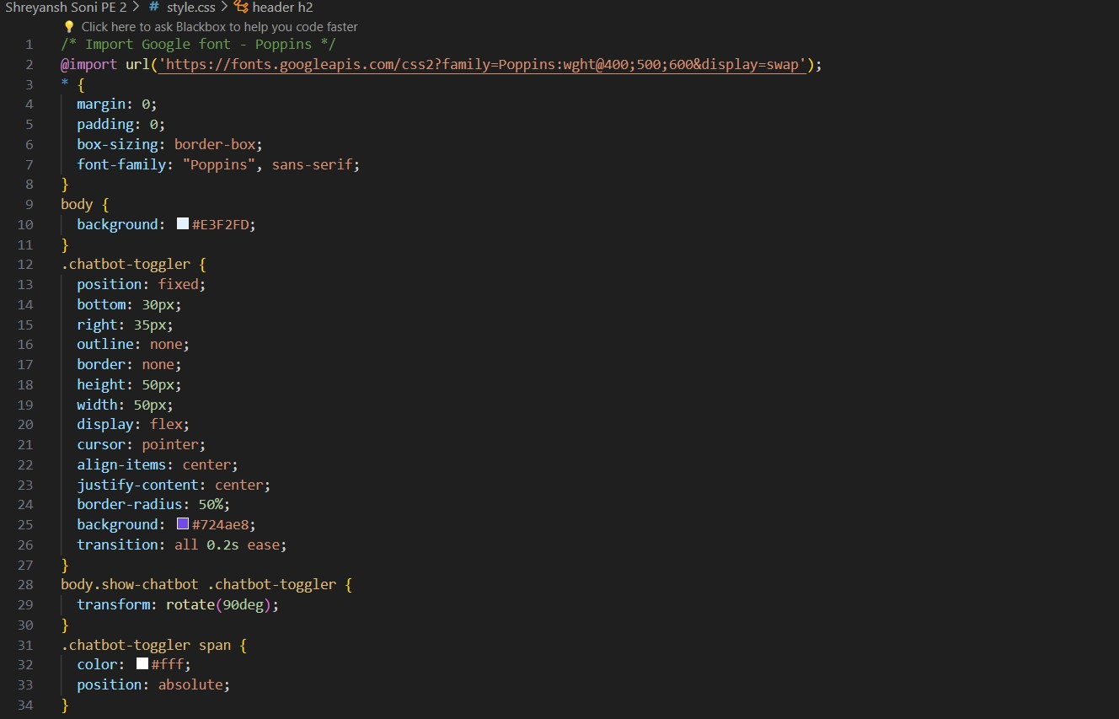
FIG C.8
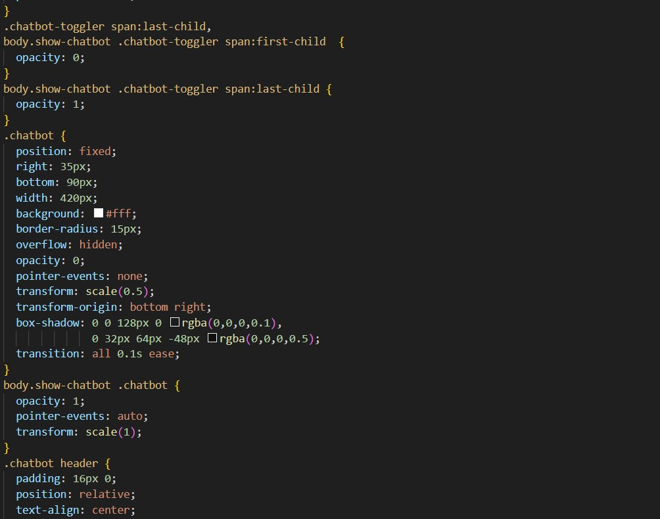
FIG C.9
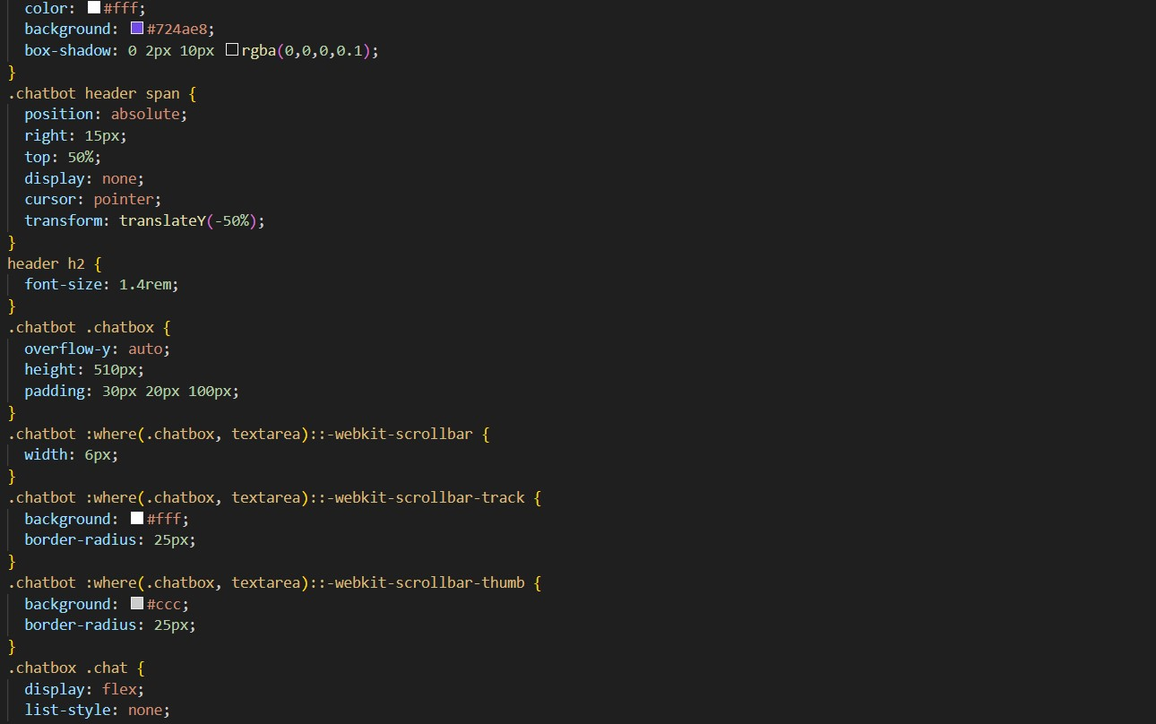
FIG C.9
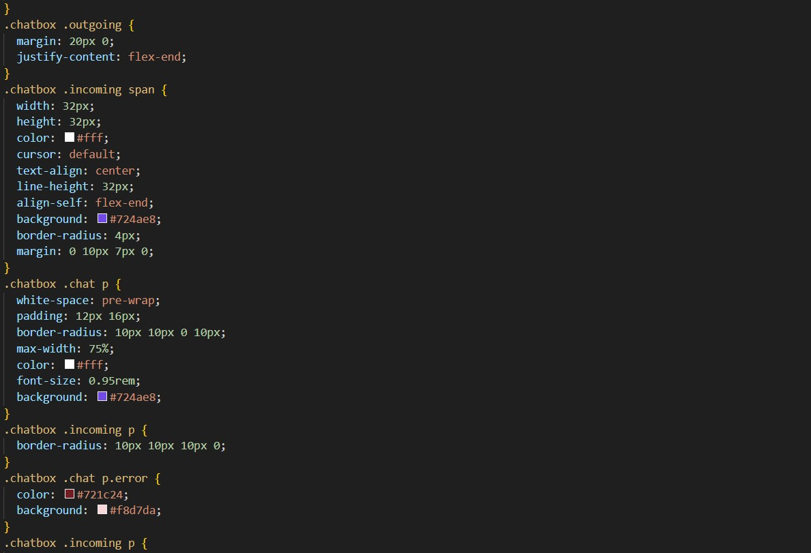
FIG C.10

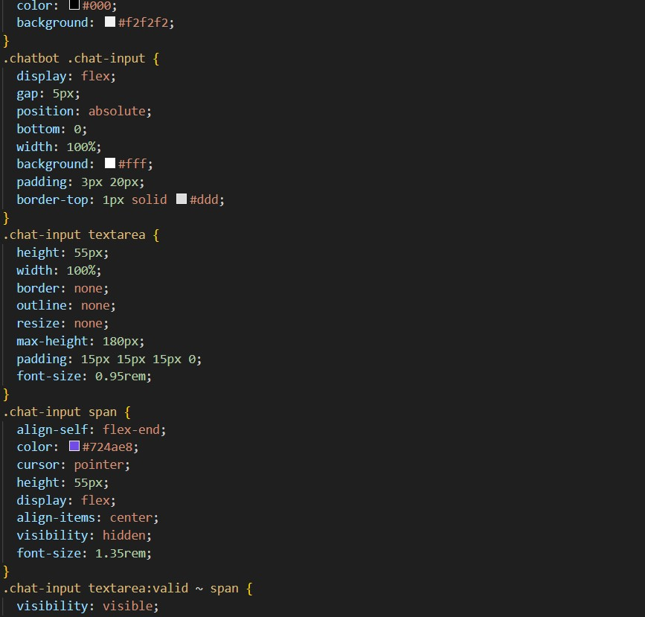
FIG C.11
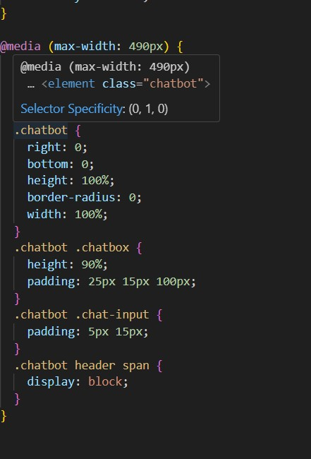
FIGC.12
Appendix D: Test Cases
Test cases outline various scenarios and expected outcomes for testing the system's functionality, performance, and security. Each test case includes detailed steps, inputs, expected results, and actual results. By presenting test cases, stakeholders can assess the thoroughness of the testing process, identify any gaps or areas for improvement, and ensure the system meets quality standards before deployment.

Appendix E: Performance Metrics
Performance metrics such as response time, throughput, and system resource utilization are presented in this section. Graphs, charts, and tables visualize performance data collected during testing and analysis of the system.

Appendix F: Privacy Policy
The privacy policy outlines the data privacy and protection measures implemented within the system to safeguard user information and ensure compliance with relevant privacy regulations. It includes details about data collection, storage, usage, sharing, and security measures. By presenting the privacy policy, stakeholders can understand how their data is handled within the system and gain confidence in its security and privacy practices.
Appendix G: User Manual
The user manual provides detailed instructions on how to use the mobile application, including step-by-step guidance for utilizing features. By presenting a user manual, stakeholders can familiarize themselves with the system's functionality, troubleshoot common issues, and maximize their use of the application.

Appendix H: Future Enhancements Roadmap
This section outlines a roadmap for future enhancements and updates to the system, including proposed features, prioritization, and estimated timelines for implementation. By presenting a future enhancements roadmap, stakeholders can understand the system's evolution over time, contribute ideas for improvement, and align development efforts with strategic objectives.

REFERENCES
1.GITHUB- https://github.com/CopilotKit/CopilotKit
2.CHATGPT- https://chatgpt.com/c/9a8bc6b9-3d3f-47e7-a10a-560f8a5ec989
3.BOTPRESS- https://app.botpress.cloud/workspaces/wkspace_01HVF4S27ETMTR56FTVQC5FR25/home
4.RAPIDAPI- https://rapidapi.com/studio#createapi

